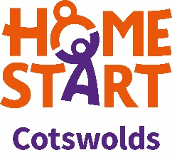
Volunteer Equality and Diversity Monitoring Form

Home-Start Cotswolds is committed, under the Equality Act 2010, to encouraging equality and diversity in the make-up of the workforce.
Please help by filling in this form.

Gender female Male Other Prefer not to say
Date of Birth day month year

Ethnic Group
White
English Welsh Scottish Northern Irish Irish
British Gypsy or Irish Traveller Prefer not to say
Any other white background, please write in:

Mixed/multiple ethnic groups
White and Black Caribbean White and Black African White and Asian
Prefer not to say
Any other mixed background, please write in:

Asian/Asian British
Indian Pakistani Bangladeshi Chinese Prefer not to say
Any other Asian background, please write in:

Black/ African/ Caribbean/ Black British
African Caribbean Prefer not to say
Any other Black/African/Caribbean background, please write in:

Other ethnic group
Arab Prefer not to say Any other ethnic group, please write in:

Do you consider yourself to have a disability or health condition?
Yes No Prefer not to say

What is the effect or impact of your disability or health condition on your ability to give your best at work? Please write in here:
The information in this form is for monitoring purposes only. If you believe you need a ‘reasonable adjustment’, then please discuss this with a Coordinator.

